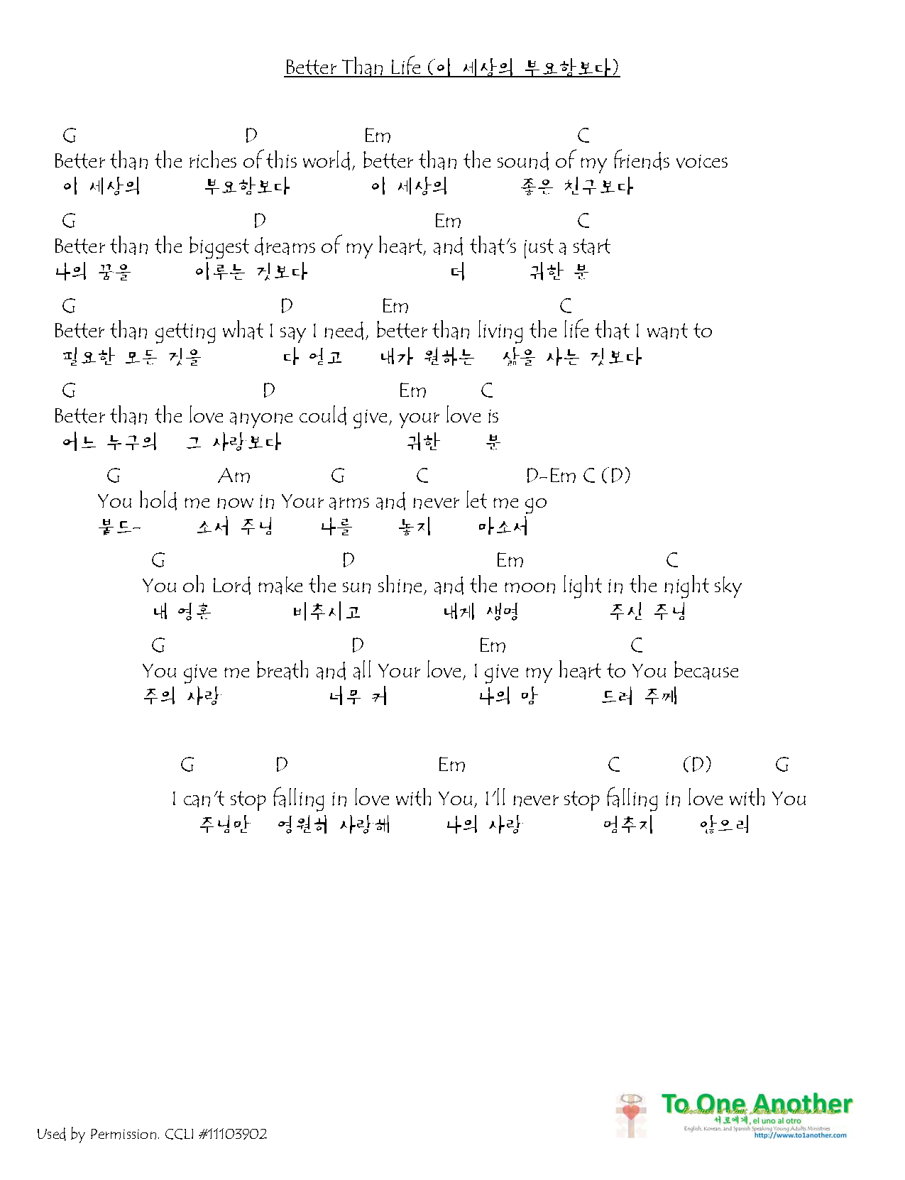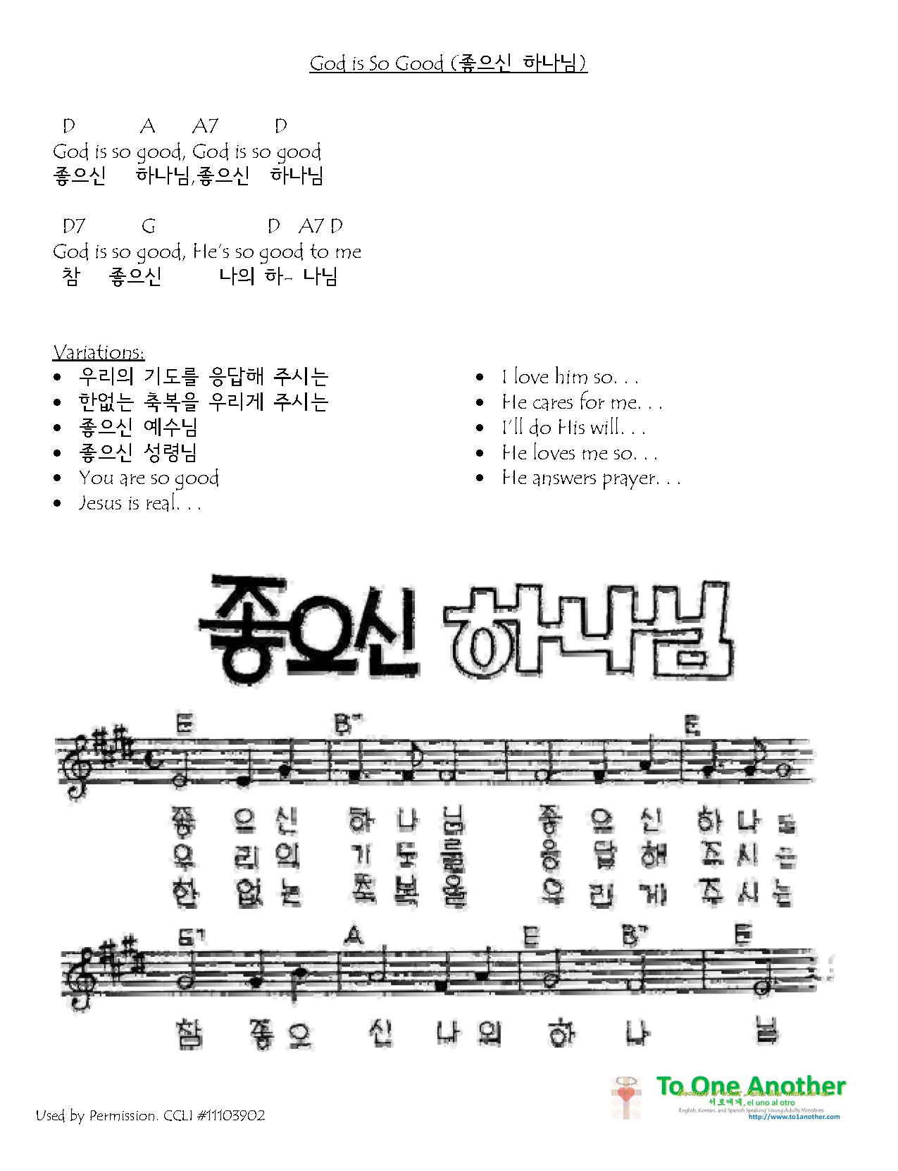

Used by Permission. CCLI #11103902 

Used by Permission. CCLI #11103902 



Used by Permission. CCLI #11103902 